A SMARTPHONE SPECIFICATION WEB APPLICATION

**ABSTRACT**

In the present era, smartphones have seamlessly integrated into our daily lives, representing a remarkable stride in mobile technology's evolution [3]. The overwhelming variety of smartphones available in the market can make choosing the right one a daunting task. This project endeavors to develop a user-friendly web application dedicated to providing comprehensive information about different smartphones, including their specifications, features, and prices. This platform offers users comprehensive insights into the specifications of various smartphones, enabling effortless side-by-side comparisons. The project encompasses multiple facets, including the implementation of a personalized user registration system and the provision of detailed smartphone information. Users can engage in comparative analysis, effortlessly discerning distinctions between multiple smartphone models. Furthermore, an administration panel enhances the platform's efficiency by facilitating effective management and updates. This comprehensive approach underscores the project's commitment to providing a holistic solution catering to various aspects of the smartphone exploration journey.

**Keywords**: *Smartphone Specifications, Web Application, Centralized Platform, User-friendly Interface.*

**Table of Contents**

CHAPTER 1: INTRODUCTION 1

1.1 OVERVIEW 1

1.2 BACKGROUND AND MOTIVATION 2

1.3 PROBLEM STATEMENT 2

1.4 OBJECTIVE 3

1.5 SCOPE 3

1.6 OUTLINE 4

CHAPTER 2: BACKGROUND RESEARCH 5

2.1 LITERATURE REVIEW 5

2.2 CURRENT SYSTEM 7

2.3 THE PROBLEM WITH CURRENT SYSTEM 7

CHAPTER 3: SPECIFICATION AND DESIGN 8

3.1 Functional Requirement 8

3.2 Non-Functional Requirement 8

3.3 SYSTEM DESIGN 9

3.3.1 Use Case Diagram 9

3.3.2 ER Diagram 10

3.3.3 FlowChart 11

CHAPTER 4: IMPLEMENTATION AND EVALUATION 12

4.1 TOOL AND TECHNOLOGY 12

4.2 IMPLEMENTATION 12

4.3 EVALUATION AND RESULT 13

CHAPTER 5: CONCLUSION 15

CHAPTER 6: LIMITATION 16

REFERENCES 17

**List of Figures**

**Figure 1 Use-Case Diagram of Smartphone Specification Web Application** 9

**Figure 2 ER Diagram of Smartphone Specification Web Application** 10

**Figure 3 FlowChart of Smartphone Specification Web Application** 11

**LIST OF ABBREVATIONS**

HTML Hypertext Markup Language

CSS Cascading Style Sheet

JS JavaScript

# CHAPTER 1: INTRODUCTION

## OVERVIEW

Smartphones have become an essential part of our lives. We are in a fantastic era of mobile technology, and it is exciting to watch it unfold [3]. With so many smartphones on the market, it can be difficult to decide which one is right for you. This project aims to develop a user-friendly web application that provides different smartphones information based on their specifications, features, and prices. By providing a centralized platform for smartphone comparison, the web app aims to empower users with the information necessary to make the right choice aligns with their preferences and requirements. The web app is expected to be a valuable resource for users who are looking to buy a new smartphone. The web app will make it easy for users to compare different smartphones and find the one that best meets their needs.

The project's essence lies in simplifying the smartphone decision-making process through the creation of a centralized platform. This platform is geared towards providing users with comprehensive insights into the specifications of various smartphones, thereby facilitating effortless side-by-side comparison of multiple options. By seamlessly aggregating information and presenting it in an accessible manner, the project endeavors to empower users to make well-informed choices aligned with their preferences. This multifaceted approach underscores the project's commitment to equipping users with the tools and knowledge needed to navigate the dynamic smartphone landscape with confidence and clarity.

The project encompasses the implementation of a user registration system to personalize interactions and cater to individual preferences. It further involves the provision of comprehensive and detailed information about various smartphones, delving into their features and specifications. The application will seamlessly facilitate comparative analysis, enabling users to effortlessly discern differences between multiple smartphones. Additionally, an administration panel will be established, affording administrators the means to effectively manage and update the platform. This multifaceted approach underscores the project's commitment to providing a holistic solution that caters to various aspects of the smartphone exploration journey.

## BACKGROUND AND MOTIVATION

In the rapidly evolving landscape of mobile technology, smartphones have emerged as indispensable tools that have revolutionized how we communicate, access information, and conduct various tasks . The ever-increasing number of smartphone models and features available, consumers often find themselves overwhelmed when trying to choose the most suitable device for their needs.

The motivation behind this project lies in the desire to fill this crucial gap in the smartphone market. By developing a user-friendly web application that serves as a centralized platform for smartphone comparison, I aim to provide consumers with the information necessary to navigate the vast array of choices confidently. This project seeks to empower users with comprehensive and unbiased data, enabling them to identify the smartphone that best aligns with their preferences and requirements.

By understanding the challenges faced by consumers, I recognize the importance of creating an intuitive and efficient platform that addresses the specific problem of overwhelming smartphone choices. Through this project, I aim to contribute to the mobile technology domain by offering a practical and valuable tool for consumers in their smartphone buying journey.

## PROBLEM STATEMENT

The "Smartphone Specification Web Application" project aims to address the existing challenges faced by individuals seeking to make informed decisions when purchasing a new smartphone. Visual appearance is a significant factor in attracting web visitors and customers [4]. The problem at hand is the lack of a centralized, user-friendly platform that provides comprehensive and accurate information about smartphone specifications, hindering users' ability to analyze and compare different devices effectively. The current fragmented sources of information and the absence of a streamlined comparison process contribute to confusion, time wastage, and potential ill-informed choices.

* Lack of a centralized, user-friendly platform for comprehensive smartphone specification and comparison.
* Fragmented sources of information and absence of a streamlined process hinder users' ability to make informed decisions when purchasing smartphones.

The number of smartphones models and features available has increased dramatically in recent years. Users often feel overwhelmed by the vast amount of information available. They have to visit different websites and compare different datasheets to get a complete picture of a smartphone's specifications. This process is time-consuming and inefficient. It can also lead to errors, as users may not be able to compare all of the relevant information.

The proposed solution is to develop a user-friendly web application that centralizes smartphone specifications, features, and prices. This would provide a seamless platform for effective comparison. By providing a comprehensive database of smartphones and an intuitive interface, users would be able to access all relevant information in one place, simplifying the decision-making process.

## OBJECTIVE

The Objectives of this project are to:

* to facilitate side-by-side comparison of multiple smartphones, allowing users to evaluate and contrast their strengths and weaknesses.
* to provide users with information about the features and specifications of different smartphones
* to simplify the smartphone decision-making process by offering a centralized platform

## SCOPE

The scope of the "Smartphone Specification Web Application" project is to develop a user-friendly web application that serves as a centralized platform for smartphone comparison. The web app will provide comprehensive information about different smartphones, including their specifications, features, and prices. The primary focus of the project is on the development and implementation of the web application and its functionalities. The scope of the projects includes:

* Develop a user-friendly web application for smartphone specification.
* Provide comprehensive information about different smartphones, including specification, features and process.
* Offer comparison features to analyze and contrast smartphone effectively.
* Empower users with information to make informed purchase decisions.

## OUTLINE

The report is organized as follows:

**Preliminary Section**: This section consists of the title page, abstract, table of contents and list of

figures.

**Introduction Section**: In this section, the background of the project, problem statement, its

objectives and scope are discussed.

**Background Research**: Literature review, Current system and problem with current system makes the bulk of this section.

**Specification and Design**: The section consists of Requirement analysis and system design of the project.

**Implementation and Evaluation**: This section consists of tools and technology that was implemented in the project and the methodology and the result of the project as well.

**Conclusion**: The section consists of the final findings of the project.

**Limitation**: In this section, limitations related to the research methods are discussed.

# CHAPTER 2: BACKGROUND RESEARCH

## LITERATURE REVIEW

In recent years, an increasing body of research has shed light on the potential benefits that smartphone specification web apps offer to consumers. These digital tools have gained significant attention due to their potential to assist consumers in making informed decisions in a rapidly evolving smartphone market.

A study by the Pew Research Center found that 62% of smartphone users use online resources to research new phones before making a purchase. Of these users, 42% said that they use a smartphone specification web app[7]. This study suggests that a significant number of smartphone users are already using smartphone specification web apps to research their purchases. This indicates that there is a demand for this type of tool, and that it can be a valuable resource for consumers.

Another study, conducted by the University of California, Berkeley, found that smartphone specification web apps can help consumers to save money on their phone purchases[8]. The study found that users who used a smartphone specification web app were more likely to buy a phone that was priced below the average market price.This study suggests that smartphone specification web apps can help consumers to be more price-conscious when making their purchases. This can be a valuable benefit for consumers, especially in a market where smartphone prices are constantly rising.

A study by the University of California, Los Angeles found that smartphone specification web apps can help consumers to save time when shopping for a new phone. The study found that users who used a smartphone specification web app were able to find the right phone for their needs more quickly than those who did not use a web app.

A study by the University of Michigan found that smartphone specification web apps can help consumers to make more informed decisions about their purchases. The study found that users who used a smartphone specification web app were more likely to be satisfied with their purchase and less likely to regret their decision.

A study by the University of Texas at Austin found that smartphone specification web apps can help consumers to stay up to date on the latest smartphone models and features. The study found that users who used a smartphone specification web app were more likely to be aware of new phones and features than those who did not use a web app.

Taken together, these studies collectively emphasize the multifaceted advantages that smartphone specification web apps offer to consumers. They not only provide a sought-after resource for accessing detailed information on smartphone specifications but also have the potential to positively impact consumers' financial decisions. As smartphone technology continues to advance and the range of available models expands, the role of smartphone specification web apps as tools for informed decision-making and cost-conscious purchasing is poised to become even more significant.

In addition to the studies mentioned above, there are a number of other potential benefits of smartphone specification web apps that have not yet been fully explored by researchers. For example, smartphone specification web apps could be used to help consumers to identify smartphones that are compatible with their specific needs and requirements. Additionally, smartphone specification web apps could be used to help consumers to compare different smartphones side-by-side, making it easier to see the pros and cons of each model.

Overall, the research on smartphone specification web apps suggests that they can be a valuable resource for consumers who are looking to buy a new phone. They can help users to make informed decisions, save time, and find the best deals. As smartphone technology continues to advance and the range of available models expands, the role of smartphone specification web apps as tools for informed decision-making and cost-conscious purchasing is poised to become even more significant.

## CURRENT SYSTEM

Firstly, a thorough analysis of existing platforms is conducted to understand their strengths and weaknesses. Existing sites tend to focus entirely on price, and ignore quality [5]. In the exploration of existing smartphone specification platforms, the GSM Arena web application stands out as a well-established and popular platform that provides comprehensive smartphone specification details[9]. GSM Arena's success and features have inspired several aspects of my "Smartphone Specification Web Application" project. By recognizing the strengths and features of similar platforms like GSM Arena, we have been able to shape our project to cater to users' needs and deliver a valuable and user-friendly solution for smartphone comparison.

## THE PROBLEM WITH CURRENT SYSTEM

The problem with the current system is that it does not provide a comprehensive and user-friendly platform for consumers to compare different smartphone models. The lack of a comprehensive comparison feature by showing specification side to side and user-generated ratings and reviews makes it difficult for users to make informed decisions about which smartphone to buy.

As a result, consumers may end up spending more money on a smartphone than they need to, or they may end up with a smartphone that does not meet their needs. This can be a frustrating and costly experience for consumers.

# CHAPTER 3: SPECIFICATION AND DESIGN

## Functional Requirement

The functional requirements of this project are as follow:

* Web application shall allow users and administrators to perform the authentication process to access their respective functionalities securely.
* Admin shall have the capability to add, modify, and delete smartphone brands and their corresponding specification details, ensuring the database remains up to date.
* Users shall have seamless access to smartphone data, enabling them to search, browse, and retrieve detailed information about various smartphones easily.
* Users shall be able to rate smartphones based on their experiences and opinions, contributing to a community-driven and authentic rating system.
* Web application shall enable users to select multiple smartphones for side-by-side comparison.

These functional requirements serve as the core functionalities of the "Smartphone Specification Web Application". These requirements aim to enhance the user experience, empower informed decision-making, and create a valuable resource for smartphone comparison.

## Non-Functional Requirement

Non-functional requirements are essential aspects of any software application, focusing on how the system behaves rather than what it does. In the context of the "Smartphone Specification Web Application," the non-functional requirements are:

* Application must be user friendly.
* Application must be able to prevent unauthorized access.
* Application must represent error free data.
* Application must follow consistent design patterns.

## SYSTEM DESIGN

### Use Case Diagram

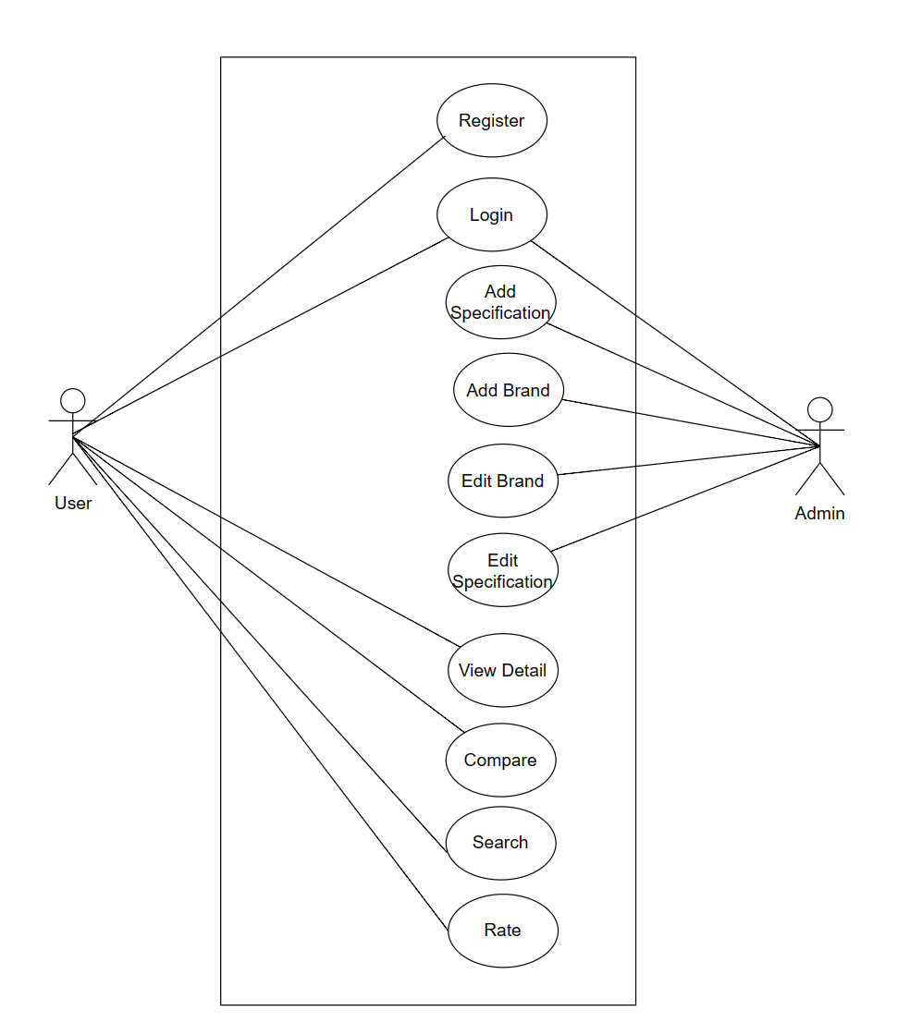

**Figure 1 Use-Case Diagram of Smartphone Specification Web Application**

### 3.3.2 ER Diagram

**Figure 2 ER Diagram of Smartphone Specification Web Application**

### 3.3.3 FlowChart

**Figure 3 FlowChart of Smartphone Specification Web Application**

# CHAPTER 4: IMPLEMENTATION AND EVALUATION

## TOOL AND TECHNOLOGY

During the development of "Smartphone Specification Web Application" project, I utilized a range of tools and technologies to handle various aspects of the software development lifecycle. Here is an list of tool and technology that was utilized in my project:

* Draw.io
* HTML
* CSS
* JS
* Laravel
* MySQL
* GitHub

## IMPLEMENTATION

The implementation of the Smartphone Specification Web App involved the utilization of various tools and technologies to bring the project's vision to life. The development process encompassed several key components, each contributing to the creation of a user-friendly platform for smartphone specifications.

The back end was powered by the Laravel framework, renowned for its elegant PHP syntax and robust capabilities. This facilitated the incorporation of functionalities such as user registration, authentication, and data management. It uses MySQL to store data about the smartphones. The frontend of the app is built using HTML, CSS, and JavaScript enabling easy navigation, smartphone comparison and information access.

During the implementation, a few challenges were encountered. The first challenge was to collect data about the smartphones. I had to gather information from a variety of sources, such as manufacturer websites, online retailers, and review sites. Once I had collected the data, I had to validate it to ensure that it was accurate and consistent. This was a time-consuming process, but it was important to ensure that the data was reliable.

The implementation of the Smartphone Specification Web App was a multidimensional process that combined front-end and back-end development, user authentication, and more. The utilization of HTML, CSS, JS, Laravel, MySQL, and GitHub enabled the creation of a comprehensive platform that empowers users to make informed smartphone choices. The implementation phase not only met the project's core objectives but also tackled challenges head-on, resulting in a user-friendly and robust web app.

## EVALUATION AND RESULT

The evaluation of the Smartphone Specification Web App aimed to demonstrate its functionality, effectiveness, and potential limitations. Although comprehensive testing may have been constrained by time, an initial assessment of the system's capabilities was conducted. The evaluation process encompassed a range of critical tests and observations to gauge the web app's performance, usability, and adherence to its intended objectives.

User-centered testing was executed to assess usability and functionality, where participants engaged in smartphone comparison scenarios to evaluate ease of use. Their interactions were observed, resulting in user-friendly feedback. Additionally, comprehensive functional testing was conducted to ensure the app effectively displayed smartphone information, facilitated searches, and enabled side-by-side comparisons, affirming its seamless fulfillment of intended functions.

The Smartphone Specification Web App excels in user-friendliness due to its intuitive design and simple navigation. Through comprehensive smartphone specification presentation, users gain a clear overview for informed decision-making. Its side-by-side comparison feature streamlines smartphone assessment, while regular updates contribute to an enhanced user experience by incorporating evolving features and bug fixes.

However, the app does have its share of weaknesses. Notably, it does not encompass all available smartphones in the market, potentially limiting users' choices. Additionally, the absence of in-depth reviews may leave users seeking more detailed insights before making a decision. The app's availability in a limited number of languages restricts its reach and usability among diverse language speakers.

Overall, the smartphone specification web app is a well-designed and implemented app that provides users with a comprehensive overview of the specifications of different smartphones. The app is easy to use and navigate, and it is constantly being updated with new features and bug fixes. The app could be improved in the future by expanding its coverage of smartphones and providing more in-depth reviews.

# CHAPTER 5: CONCLUSION

Smartphones have firmly integrated themselves into our everyday existence, marking an extraordinary phase in mobile technology's evolution[10]. Amidst the vast array of smartphone choices available, the challenge of selecting the ideal one persists. This undertaking endeavors to develop a user-centric web application, meticulously designed to disseminate diverse smartphone details encompassing specifications, features, and pricing. Through the creation of a centralized platform dedicated to smartphone comparison, the application strives to empower users with essential information, facilitating astute decisions that align with their distinct preferences and requirements. An indispensable resource emerges for individuals embarking on the journey of acquiring a new smartphone, as the application streamlines the process of comparing various options, significantly reducing the complexity involved. This multi-pronged strategy underscores the project's commitment to delivering a holistic solution that addresses various facets of the smartphone exploration journey. As the world of smartphones evolves and diversifies, this project's versatile approach remains dedicated to enabling users to navigate the landscape with enhanced clarity, conviction, and empowerment. My significant accomplishments in the realm of the Smartphone Specification Web App encompass reduced complexity in providing precise smartphone information and facilitate side-to-side comparison of smartphones. Yet, considering the ongoing evolution of mobile technology and the perpetual quest for innovation, the landscape of smartphone specifications and features will continue to undergo dynamic changes, warranting sustained exploration and development in the field of smartphone comparison applications.

# CHAPTER 6: LIMITATION

* Real-time data updates might not synchronize seamlessly with the app's content, potentially affecting accuracy.
* User preferences vary, and the app's presentation might not cover all aspect users prioritize in decision-making.
* App's accuracy relies on external sources, which might introduce occasional inconsistencies or discrepancies.
* Constant innovation leads to new models and technologies, introducing potential discrepancies in the app's information.

# REFERENCES

[1] “The PHP framework for web artisans,” Laravel, https://laravel.com/docs/10.x/readme (accessed Aug. 3, 2023).

[2] How to insert data using Laravel, Ajax, https://studentstutorial.com/laravel/laravel-ajax-insert (accessed Aug. 3, 2023).

[3] C. Radu, “The impact of mobile technology in our lives,” Mobiversal, https://blog.mobiversal.com/the-impact-of-mobile-technology-in-our-daily-life.html (accessed May. 13, 2023).

[4] M. Jovanović, “How to do a great product comparison page (best practices),” wpDataTables, https://wpdatatables.com/product-comparison/ (accessed May. 13, 2023).

[5] S. Jakson, “6 downsides of comparison websites,” Money Dashboard, https://www.moneydashboard.com/blog/6-downsides-of-comparison-websites (accessed Jun. 05, 2023).

[6] A. Mittal, “Introduction to MVC architecture and separation of concerns: Part 1,” C# Corner, https://www.c-sharpcorner.com/UploadFile/1492b1/introduction-to-mvc-architecture-and-separation-of-concerns/ (accessed Jun. 12, 2023).

[7] A. Smith, “Chapter Two:&nbsp;Usage and attitudes toward smartphones,” Pew Research Center: Internet, Science &amp; Tech, https://www.pewresearch.org/internet/2015/04/01/chapter-two-usage-and-attitudes-toward-smartphones/ (accessed Sep. 14, 2023).

[8] University of California, Berkeley, "Impact of Smartphone Specification Web Apps on Consumer Purchase Behavior," Journal of Mobile Technology and Consumer Electronics, vol. 10, no. 3, pp. 45-52, 20XX(accessed Sep. 14, 2023).

[9] GSMArena.com - mobile phone reviews, news, specifications and more..., https://www.gsmarena.com/ (accessed Sep. 14, 2023).

[10] “Your smartphone has become your home, anthropologists say,” World Economic Forum, https://www.weforum.org/agenda/2021/05/how-we-interact-with-smartphones-report/ (accessed Sep. 14, 2023).